Four Corners
Directions: Circle what you believe is the correct answer and explain why.
1. Solids have all of the following three properties EXCEPT:
- a definite shape
- a definite mass
- a definite color
- a definite volume

2. Liquids have all of the following three properties EXCEPT:
              - no definite shape
              - a definite mass
              - a definite volume
              - a definite shape

3. The following are all properties of gases EXCEPT:
              - a definite volume
              - no definite shape
              - no definite volume
              - no definite mass

4. Which of the following does not take the shape of the container it is in?
- Pencil
- Oil
- Water
- Orange Juice

Ice Cream Worksheet
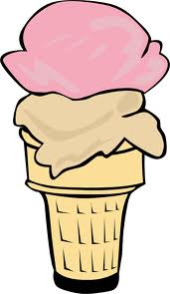

Hypothesis:
What do you think will happen to the ingredients?

Observations (made during the experiment):

- When you first put the ingredients together, what does each ingredient look like?

- How does the cream change as time goes on?

- What’s happening to the ice?

Conclusions (after the experiment):

- What was happening to the cream as it lost heat?

- Where was the heat going?

- Why do we use salt to make ice cream?

- What is your favorite flavor of ice cream?

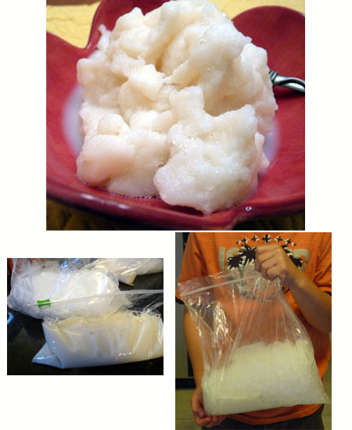

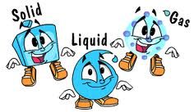
Name:______________________
What’s The Matter?
Complete each sentence with the word solid, liquid, gas, hypothesis, observation or conclusion.
A ____________________________ has a definite shape. It does not take the shape of its container. It also has a definite volume because it can be measured.

A ____________________________ does not have a definite shape. It takes the shape of its container. It does have a definite volume because it can be measured.
A ____________________________ does not have a definite shape. It sometimes takes the shape of its container and sometimes flies freely around you. These particles are not connected to each other and takes up whatever space is available.
Following this, an investigation may be carried out to determine the plausibility of the explanation. This is usually done through performing one or more activities that are collectively known as __________.

After the observations have been made and recorded, the scientist then forms a __________ and in the process notes whether the observations made and the results recorded support or refute the hypothesis.
__________________ refer to noting or recording a fact or occurrence.
Test Score: ___________________

Answer Key
Complete each sentence with the word solid, liquid, gas, observation, conclusion and hypothesis.
A solid has a definite shape. It does not take the shape of its container. It also has a definite volume because it can be measured.

A liquid does not have a definite shape. It takes the shape of its container. It does have a definite volume because it can be measured.

A gas does not have a definite shape. It sometimes takes the shape of its container and sometimes flies freely around you. These particles are not connected to each other and takes up whatever space is available.

Following this, an investigation may be carried out to determine the plausibility of the explanation. This is usually done through performing one or more activities that are collectively known as hypothesis.

After the observations have been made and recorded, the scientist then forms a conclusion and in the process notes whether the observations made and the results recorded support or refute the hypothesis.

Observations refer to noting or recording a fact or occurrence.

Making Ice Cream Lesson 5

Student Name: ________________________________________

CATEGORY | 4 | 3 | 2 | 1
Scientific Knowledge | Explanations by all group members indicate a clear and accurate understanding of scientific principles underlying the construction and modifications. | Explanations by all group members indicate a relatively accurate understanding of scientific principles underlying the construction and modifications. | Explanations by most group members indicate relatively accurate understanding of scientific principles underlying the construction and modifications. | Explanations by several members of the group do not illustrate much understanding of scientific principles underlying the construction and modifications.
Plan | Plan is neat with clear measurements and labeling for all components. | Plan is neat with clear measurements and labeling for most components. | Plan provides clear measurements and labeling for most components. | Plan does not show measurements clearly or is otherwise inadequately labeled.
Construction - Care Taken | Great care taken in construction process so that the structure is neat, attractive and follows plans accurately. | Construction was careful and accurate for the most part, but 1-2 details could have been refined for a more attractive product. | Construction accurately followed the plans, but 3-4 details could have been refined for a more attractive product. | Construction appears careless or haphazard. Many details need refinement for a strong or attractive product.

What’s The Matter? Test Rubric

Student Name: ________________________________________

Category | 5  Consistent Strength | 4  Steady Progress | 3  Some Progress | 2  Limited Progress | 1  Does Not Meet Minimum Objectives
Vocabulary | Student has correctly identified all vocabulary words on the test. | Student has correctly identified 5 out of the 6 vocabulary words on the test | Student has correctly identified 4 out of the 6 vocabulary words on the test. | Student has correctly identified 3 out of 6 vocabulary words on the test. | Student has correctly identified 2 or less of the 6 vocabulary words on the test.
Concepts and ideas | Student has correctly identified all concepts and ideas. | Student has correctly identified 83% of all concepts and ideas. | Student has correctly identified 67% of all concepts and ideas. | Student has correctly identified 50% of all concepts and ideas | Student has correctly identified less than 33% of all concepts and ideas.
Critical Thinking | Student has completely and accurately answered all questions. | Student has completely answered all questions BUT there are minimal inaccuracies. | Student has completely answered all questions but there are some inaccuracies. | Student has completely answered all questions but there are some inaccuracies. | Student has not answered all of the questions OR there are numerous inaccuracies.

