

**References**

* **Mrs.Lori Kirshman**

Principal

Moorsbridge Elementary

7361 Moorsbridge Rd

Portage, Michigan 49024

(269) 323-6455

LKirshman@portageps.org

* **Mrs. Gina Middleton**

Preschool Teacher

The Discovery Center

4102 West Michigan Avenue

Kalamazoo, Michigan 49006

(269) 372-0007

* **Mrs. Jennifer Carson**

2nd Grade Teacher

Haverhill Elementary

6633 Haverhill Avenue

Portage, Michigan 49024

(269) 323-6208

# My Teaching Philosophy

* Encourage parental involvement
* Honor diversity in the classroom

* Use a variety of teaching methods
* Have high expectations for myself and the students
* Assess students’ understanding regularly
* Provide proper classroom management
* Create a successful learning environment



<EMPTY>

**In Houston, Texas, I was able to practice my philosophy in a first grade classroom of ESL learners.**

My Contact Information

Phone: (269) 370-5987

E-mail: MeganMuz@aol.com

Address: 6995 East U.V. Avenue

Vicksburg, MI, 49097

http://instructionalstrategiesportfolio.weebly.com

**Spring Arbor University**

**Bachelor of Arts**

**Major in Early Childhood**

**Minor in English as a Second Language**

**Certified General Education K-5**

**MLPP Certified**

A teacher is a compass that activates the magnets of curiosity, knowledge, and wisdom in the pupils.

~Ever Garrison

Megan Muzljakovich



 <EMPTY>

**Over 120 hours in a variety of K-12 general, ESL, early childhood and special education**

**classrooms**

**Intern**

Vicksburg Community Summer School

* Tutored students in reading for 2 years
* Assisted students with learning disabilities
* Collaborated with general education teachers.

Moorsbridge Elementary

* Designed unit lesson plans for a second grade classroom
* Assumed full responsibility for a second grade classroom
* Attended Workshops and Conferences

Discovery Center

* Assistant teacher for 8 weeks in a preschool classroom.
* Created a unit plan for a preschool and infants.

Lincoln Elementary

* Taught English to non-native speakers
* Created individual lesson plans for my ESL students
* Helped out with the ESL program before and after school.

**Mentor**

Vicksburg High School

* Tutored students through the “Be the Change” organization
* Supported students by listening to their dilemmas
* Helped them with their organization of coursework.

**Church Volunteer**

* Assistant leader at vacation bible school for eight years
* Provided necessities and shelter after hurricane Emily in Mexico
* Helped out at orphanages in Guatemala

**Experience & Skills**

**Management:**

* Rules and procedures will be consistently modeled and practiced.
* My classroom will be organized to create a safe learning environment.
* I will have positive expectations for myself as well as my students.

**Assessment:**

My assessments will…

* have a clear purpose
* further learning
* inform instruction
* communicate the objectives mastered
* motivate the students
* provide evidence of student learning
* be based on the RTI model and differentiations

“Timely and appropriate feedback should give students a better understanding of their own progress and encourage them to improve.”

-Robert Marzano

**Strategies**

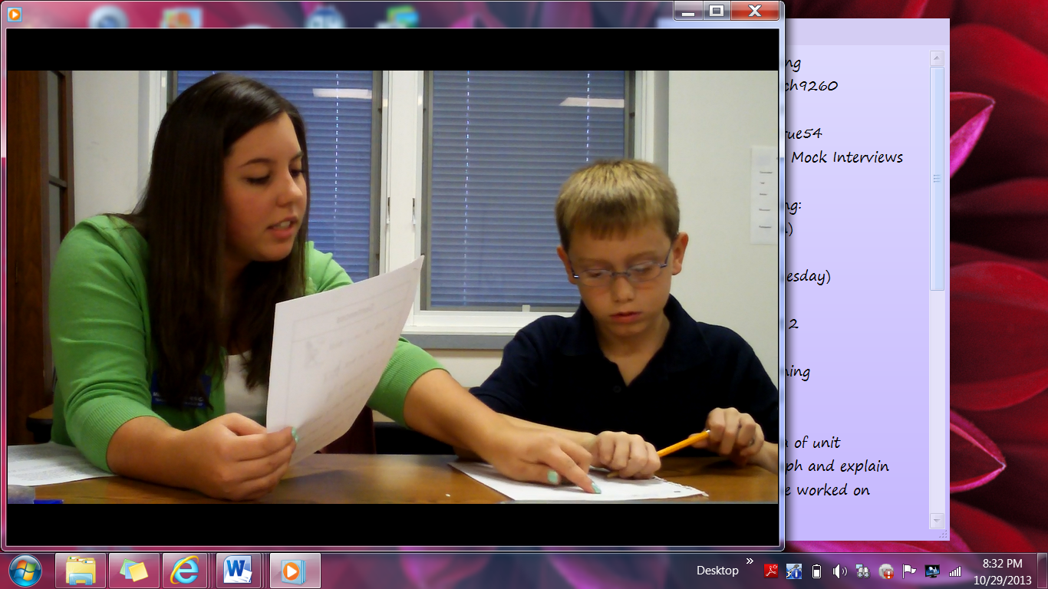

* Learning Centers will help manage and differentiate instruction.
* KWL charts will help the students divide up what they know, what they want to know, and what they learned in a lesson.
* Scaffolding Writing will help students illustrate what they are writing about.
* Technology will be incorporated into my lessons to further instruction through lessons.
* I have compiled a list of instructional strategies through education courses and research. If you would like to see these instructional strategies (and more) implemented into the classroom, please visit the following website:

**www.instructionalstrategiesportfolio.weebly.com**

* I will differentiate instruction in order to fit the needs of all of my students, and I will use numerous strategies to guarantee that every child succeeds.

**Management & Assessment**